Experiment 3: Show Outline of an Image using Canny Function
Software / Tools: Python · OpenCV (cv2)

AIM
To detect and display the edges/outline of an image using the Canny edge detection algorithm.
ALGORITHM
1. Import OpenCV.
2. Read the input image.
3. Convert the image to grayscale (Canny works on single-channel images).
4. Apply cv2.Canny() with lower and upper threshold values (e.g. 100, 200).
5. Display and save the resulting edge/outline image.
PROGRAM (SOURCE CODE)
import cv2

img = cv2.imread("image.jpg")
gray_img = cv2.cvtColor(img, cv2.COLOR_BGR2GRAY)

# Apply Canny Edge Detection
edges = cv2.Canny(gray_img, threshold1=100, threshold2=200)

cv2.imwrite("outline_output.jpg", edges)
cv2.imshow("Outline (Canny Edges)", edges)
cv2.waitKey(0)
cv2.destroyAllWindows()

OUTPUT
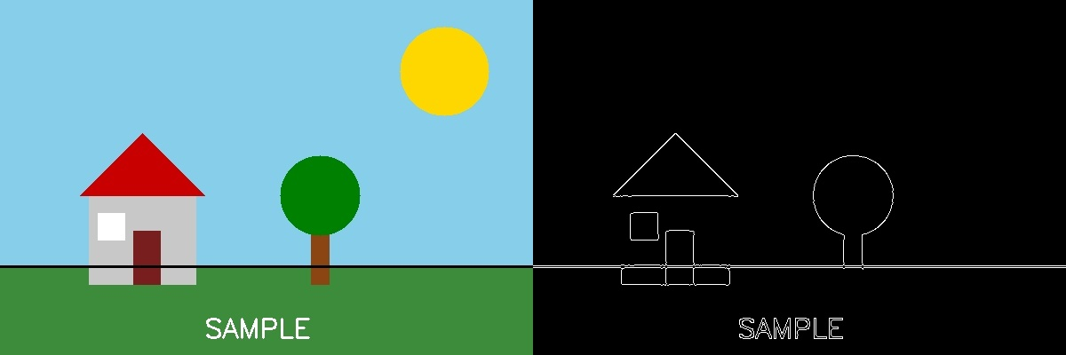
Fig. 3 — Output of Experiment 3: Show Outline of an Image using Canny Function.
RESULT
Detect and display the edges/outline of an image using the Canny edge detection algorithm — completed successfully, as demonstrated in the output shown above.

